M.PARAMESH
ECE
VLSI
MINOR PROJCET (VLSI)

Design a Simplified Vending Machine Controller using Finite State Machine (FSM) concepts in Verilog HDL.

VLSI stands for Very-Large-Scale Integration. It is the process of integrating millions (or even billions) of transistors onto a single semiconductor chip to build complex circuits and systems. VLSI technology is the foundation of modern integrated circuits (ICs) used in devices such as microprocessors, memory chips, FPGAs, and SoCs (System-on-Chip).
- Technology Type: Microelectronics
- Application: Used in ICs for computers, mobile phones, embedded systems, etc.

Introduction
A vending machine is an automated system that dispenses products after receiving a specific amount of money. This project focuses on designing a simple vending machine controller using a Finite State Machine (FSM) in Verilog. The machine accepts ₹5 and ₹10 coins and dispenses a product when the total reaches ₹15. The design is implemented and tested through simulation, demonstrating how FSMs can control digital systems efficiently and accurately.

Abstract
This project presents the design and simulation of a Finite State Machine (FSM)-based vending machine controller using Verilog HDL. The system is designed to accept ₹5 and ₹10 coins and dispense a product when the total inserted amount reaches ₹15. The FSM architecture uses four defined states to represent the cumulative amount of money inserted: ₹0, ₹5, ₹10, and ₹15. Upon reaching ₹15, the system activates the dispense output signal for one clock cycle to release the product and automatically resets to its initial state. No change return or refund mechanism is implemented to simplify the logic. A comprehensive testbench is developed to validate the design under different coin input sequences. Simulations are performed using Vivado, and the waveform analysis confirms the correct functionality of the FSM. This project demonstrates the effectiveness of FSMs in implementing simple embedded control systems like vending machines in digital design environments

FSM STATE DIAGRAM
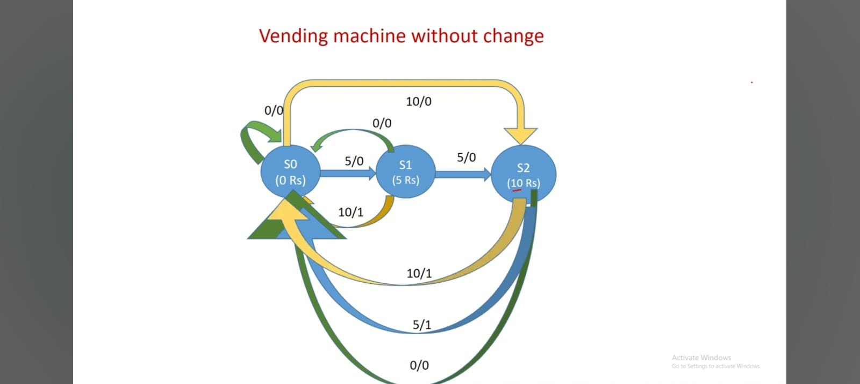

States:
- S0: Initial state (₹0 inserted).
- S5: ₹5 inserted.
- S10: ₹10 inserted.
- S15: ₹15 inserted (dispense state).

Explanation of code
- clk: Clock signal.
- rst: Reset signal.
- coin: 2-bit input representing the coin inserted.
- dispense: Output from the vending machine indicating item dispensing.
- coin = 2'b01 → ₹5
- coin = 2'b10 → ₹10
- coin = 2'b00 → No coin input or idle

Design code
module vending_machine (
input clk,
input rst,
input [1:0] coin, // 2'b01 = ?5, 2'b10 = ?10
output reg dispense
);
// State encoding using parameters
parameter S0 = 2'd0; // ?0 inserted
parameter S5 = 2'd1; // ?5 inserted
parameter S10 = 2'd2; // ?10 inserted
parameter S15 = 2'd3; // ?15 or more inserted
reg [1:0] state, next_state;
// Sequential logic: state register
always @(posedge clk or posedge rst) begin
if (rst)
state <= S0;
else
state <= next_state;
end
// Combinational logic: next state and output
always @(*) begin
dispense = 0;
case (state)
S0: begin
case (coin)
2'b01: next_state = S5; // ?5 inserted
2'b10: next_state = S10; // ?10 inserted
default: next_state = S0;
endcase
end
S5: begin
case (coin)
2'b01: next_state = S10; // ?5 + ?5 = ?10
2'b10: next_state = S15; // ?5 + ?10 = ?15
default: next_state = S5;
endcase
end
S10: begin
case (coin)
2'b01: next_state = S15; // ?10 + ?5 = ?15
2'b10: next_state = S15; // ?10 + ?10 = ?20
default: next_state = S10;
endcase
end
S15: begin
dispense = 1; // Dispense the product
next_state = S0; // Reset FSM
end
default: next_state = S0;
endcase
end
endmodule

Simulation code
`timescale 1ns / 1ps
module vending_machine_tb;
// Inputs
reg clk;
reg rst;
reg [1:0] coin;
// Output
wire dispense;
// Instantiate the DUT (Device Under Test)
vending_machine uut (
.clk(clk),
.rst(rst),
.coin(coin),
.dispense(dispense)
);
// Generate clock signal: 10ns period (100MHz)
always #5 clk = ~clk;
initial begin
// Initialize signals
clk = 0;
rst = 1;
coin = 2'b00;
// Hold reset for 10ns
#10;
rst = 0;
// Test Case 1: ?5 + ?5 + ?5 = ?15 ? Dispense
coin = 2'b01; // ?5
#10;
coin = 2'b01; // ?5
#10;
coin = 2'b01; // ?5 ? should dispense
#10;
// Test Case 2: ?10 + ?5 = ?15 ? Dispense
coin = 2'b00; // Wait
#10;
coin = 2'b10; // ?10
#10;
coin = 2'b01; // ?5 ? should dispense
#10;
// Test Case 3: ?10 + ?10 = ?20 ? Overpay, still dispense
coin = 2'b00;
#10;
coin = 2'b10; // ?10
#10;
coin = 2'b10; // ?10 ? should dispense
#10;
// End simulation
$finish;
end
endmodule

Design
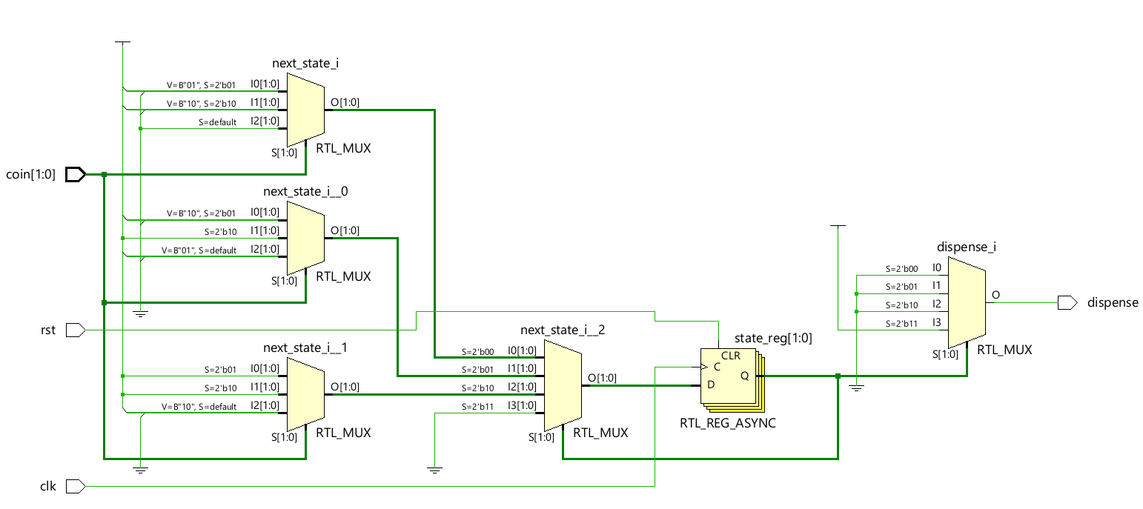

Simulation
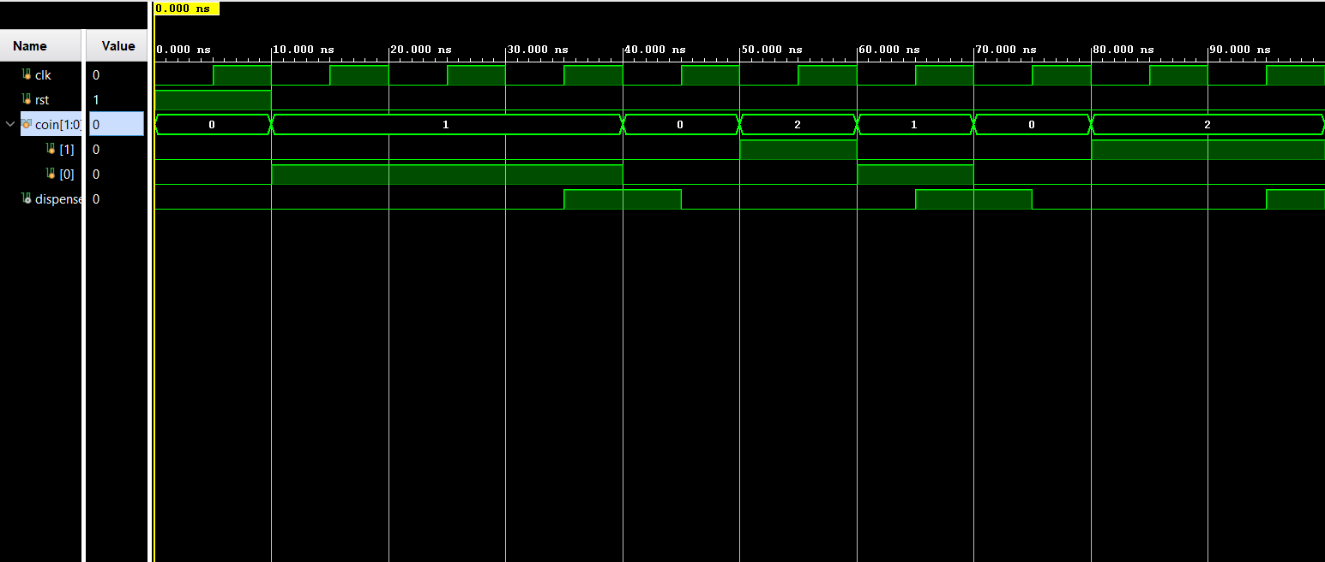

Result
Time | Coin Value | Cumulative Total | Expected Output
10ns | ₹5 | ₹5 | 0
20ns | ₹5 | ₹10 | 0
30ns | ₹5 | ₹15 | dispense = 1
50ns | ₹10 | ₹10 | 0
60ns | ₹5 | ₹15 | dispense = 1
80ns | ₹10 | ₹10 | 0
90ns | ₹10 | ₹20 | dispense = 1

Conclusion
The vending machine FSM was successfully designed in Verilog to accept ₹5 and ₹10 coins and dispense a product at ₹15. Simulations confirmed that the system works correctly for all test cases, triggering the dispense signal at the right time. The project shows how FSMs can be used to implement real-time digital systems effectively.

